Advanced Risk & Model Validation
Knowing Where a Model Stops Being Trustworthy
A Level 5 module in the Quantitative Finance Curriculum
Covers: model risk / misspecification · parameter instability / regime changes · stress testing / scenario generation · tail dependence / Extreme Value Theory / copulas · backtest overfitting / parameter sensitivity / robustness · model governance / independent validation

Table of Contents
Table of Contents 1
How to Use This Guide 1
What you need to know before starting 1
Why it matters 1
How this connects to the rest of the curriculum 1
Glossary of recurring terms 1
Part 1 — Model Risk, Instability, and Overfitting 1
1.1 What Is Model Risk? A Taxonomy 1
1.2 Parameter Instability and Regime Change 1
1.3 Backtest Overfitting and Multiple Testing 1
1.4 Parameter Sensitivity and Robustness Testing 1
1.5 Worked Example: Applying the Deflated Sharpe Ratio 1
Part 2 — Tail Risk, Stress Testing, and Governance 1
2.1 Fat Tails and Extreme Value Theory 1
2.2 Tail Dependence and Copulas 1
2.3 Stress Testing and Scenario Generation 1
2.4 Model Governance and Independent Validation 1
Practical Exercise 1
Common Beginner Mistakes 1
Advanced Extensions 1
Professional Applications 1
Where to Go Next 1

How to Use This Guide
This document is a companion to Advanced Risk & Model Validation, the fifth-level module in the quantitative finance curriculum. Every earlier module in this curriculum builds a model — a pricing model, a factor model, a trading strategy, a volatility surface. This module is different in kind: it is not about building another model, but about critically evaluating any of them. It asks a single recurring question of every model encountered so far: under what conditions does this stop being trustworthy, and how would you know?
The module is organised in two halves. Part 1 covers model risk from the inside — misspecification, parameter instability, and the specific statistical trap of backtest overfitting. Part 2 covers risk from the outside — how tail events and correlated crises actually behave, how to stress-test a model against them, and the governance processes that make independent validation a routine part of running a trading or risk business rather than an afterthought.

What you need to know before starting
- Risk Metrics (Level 2) — Value-at-Risk, Expected Shortfall, volatility, and drawdown, used throughout this module as the risk measures whose validity is itself under scrutiny.
- Backtesting (Level 3) — the mechanics of building and evaluating a historical backtest — in-sample versus out-of-sample performance, transaction cost modelling, and walk-forward testing. This module assumes you can build a competent backtest and focuses on why even a competent one can still mislead you.
- Probability (tail behaviour) — distributions, moments, and enough familiarity with the normal distribution to appreciate how a fat-tailed distribution differs from it — the mathematical foundation for Section 2.1's treatment of Extreme Value Theory.
Tip: This module rewards scepticism more than technical virtuosity. If you find yourself wanting to defend a model rather than find its failure point while working through the practical exercise, that instinct is worth noticing — it is precisely the instinct independent validation exists to counteract.

Why it matters
Every model introduced in this curriculum — CAPM, Black-Scholes, a factor model, a SABR calibration, a systematic trading strategy — is a simplification of reality that is useful precisely because it is simpler than reality, and wrong in some specific, identifiable ways as a direct consequence. A model that has never failed has usually just not yet been tested outside the conditions it was built under. Professional risk management is fundamentally not about running a model's outputs and trusting the number that comes out; it is about knowing, in advance, which conditions would break the model, and having a plan for what happens when — not if — those conditions eventually occur. The 2008 financial crisis, the 2010 Flash Crash, and the 2020 COVID crash were each, in part, failures of risk models that had been quietly relied upon past the conditions under which they had ever been validated.

How this connects to the rest of the curriculum
- Research — independent validation of a colleague's strategy — stress-testing its assumptions and looking for the conditions under which it would fail, rather than simply reproducing its backtest and confirming the same number — is a distinct and valuable research skill in its own right, structurally different from the strategy-development skill taught in Level 3.
- Development — model governance is an infrastructure problem as much as a policy one: versioning every model change, recording who signed off on what and when, and building automated monitoring that flags when a live model's behaviour drifts from its validated expectations, all need to be built into research-to-production infrastructure rather than bolted on afterward.
- Trading — stress testing and scenario analysis directly inform position limits and capital allocation decisions — a desk's maximum position size in a given strategy is, in a well-run institution, set with direct reference to how that strategy performs in the stress scenarios covered in Section 2.3, not solely from its historical backtested Sharpe ratio.

Glossary of recurring terms
Model risk — The risk of loss arising from a model being wrong, misused, or applied outside the conditions under which it was validated — distinct from the market, credit, or operational risk the model itself is trying to measure.
Model misspecification — A structural error in a model's assumptions (e.g. assuming normally distributed returns when they are fat-tailed), as opposed to an error in estimating a correctly specified model's parameters.
Parameter instability — The tendency of a model's estimated parameters (a beta, a volatility, a correlation) to change materially over time, often because the underlying data-generating process itself is changing.
Regime change — A shift in the underlying statistical behaviour of markets (e.g. from low to high volatility, or from trending to mean-reverting), after which parameters estimated on the old regime no longer describe the new one.
Backtest overfitting — Selecting a strategy or parameter configuration because it performed best among many tried, so that some of its apparent historical performance reflects fitting to noise rather than genuine, repeatable skill.
Deflated Sharpe ratio — A Sharpe ratio adjusted downward to account for the number of strategy variations tried before selecting the best one, correcting for the selection bias described in Section 1.3.
Walk-forward validation — A validation scheme in which a model is repeatedly re-fitted on a rolling historical window and tested only on the immediately following, unseen period, closer to how the model would actually have been used in real time.
Extreme Value Theory (EVT) — A branch of statistics that models the tail of a distribution directly, rather than relying on a full-distribution assumption (like normality) that may fit the centre well but the tail poorly.
Tail dependence — The tendency of two variables to move together specifically during extreme events, which can be much stronger than their ordinary (e.g. Pearson) correlation would suggest.
Copula — A mathematical device that separates a joint distribution's marginal behaviour (each variable on its own) from its dependence structure (how the variables move together), allowing tail dependence to be modelled explicitly.
Stress testing — Evaluating a portfolio or model's behaviour under a specific, severe scenario — historical or hypothetical — rather than under its normal, everyday statistical assumptions.
Scenario generation — The process of constructing stress scenarios, either by replaying historical crisis periods or by constructing hypothetical ones designed to probe a specific vulnerability.
Model governance — The set of organisational processes — versioning, documentation, sign-off, and monitoring — that ensure a model is properly reviewed before deployment and properly overseen afterward.
Independent validation — Review of a model by a team or individual separate from, and without incentive to protect, the model's original developer, specifically tasked with finding its weaknesses.

Part 1 — Model Risk, Instability, and Overfitting
This part looks at model risk from the inside: the ways a model can be wrong even when it has been built, estimated, and backtested competently. It moves from a general taxonomy of model risk, to the specific problem of parameters that drift as market regimes change, to the single most common and most dangerous statistical trap in strategy research — backtest overfitting — and finally to the practical discipline of testing how sensitive a model's conclusions are to its own assumptions.

1.1 What Is Model Risk? A Taxonomy
It is useful to separate model risk into distinct categories, because each has a different cause and a different mitigation. The table below distinguishes four common sources, each of which has appeared, in different guises, in earlier modules of this curriculum.
Type of model risk | What goes wrong | Example from this curriculum
Specification risk | The model's structural assumptions do not match reality, regardless of how well its parameters are estimated. | Black-Scholes assumes constant volatility; real markets exhibit a smile (Level 5 Volatility module).
Parameter risk | The model's structure is reasonable, but the estimated parameters are wrong, stale, or unstable. | A beta estimated over a low-volatility period applied unchanged to a high-volatility regime (Section 1.2).
Implementation risk | The model's mathematics is correct but the code implementing it has a bug, a numerical instability, or a data error. | An off-by-one error in a rolling-window calculation silently using the wrong lookback period.
Selection / overfitting risk | The model was chosen, among many candidates, specifically because it performed best historically. | Testing 200 factor combinations and reporting only the best backtest (Section 1.3).
Every model failure that makes headlines is usually a combination of more than one of these. The 2008 crisis, for instance, combined specification risk (Gaussian copula models of mortgage default correlation badly understated tail dependence — the exact issue covered in Section 2.2) with parameter risk (correlations estimated over a benign housing-price period that did not hold once prices fell nationally).
Why this distinction matters: Each type of model risk needs a different kind of validation. Specification risk is caught by asking 'what does this model structurally assume, and is that assumption reasonable?' — not by re-running the same model on more data. Parameter risk is caught by monitoring stability over time. Selection risk is caught by accounting for how many alternatives were tried. Treating all model risk as one undifferentiated problem, to be solved by 'more backtesting', is itself a common validation mistake.

1.2 Parameter Instability and Regime Change
Almost every model in this curriculum estimates at least one parameter — a beta, a volatility, a correlation, a mean-reversion speed — from a finite historical window, implicitly assuming the future will resemble that window closely enough for the estimate to remain valid. Markets do not oblige indefinitely: volatility regimes shift, correlations break down and re-form (often in the wrong direction exactly during a crisis), and a relationship that has held for years can change abruptly. Figure 1.1 illustrates the problem with a rolling estimate of a stock's beta against the market.
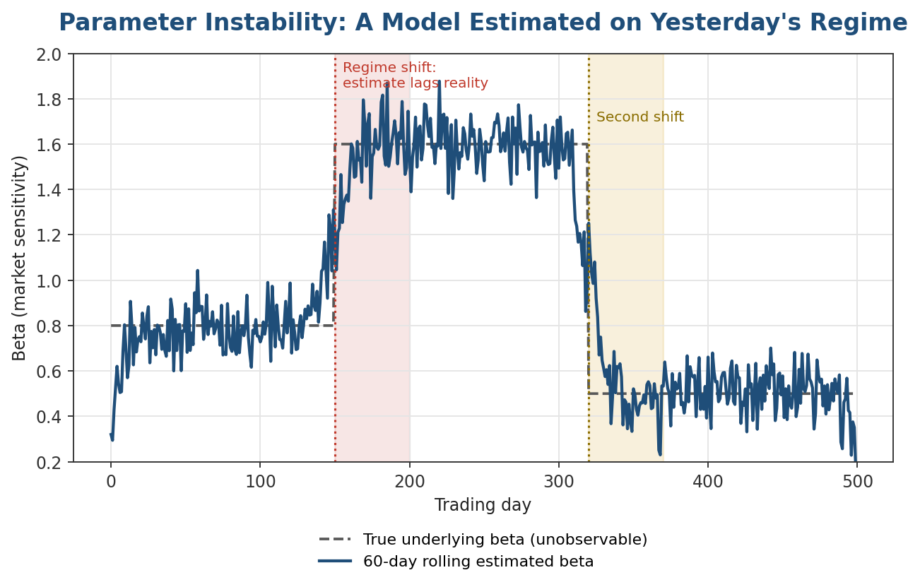
Figure 1.1 — A rolling-window estimate necessarily lags a genuine regime shift, because it is, by construction, a weighted average of old and new behaviour. The wider the estimation window, the smoother the estimate but the slower it reacts.
This creates an unavoidable trade-off: a short estimation window reacts quickly to genuine regime changes but is noisy and easily fooled by random short-term fluctuations; a long window is stable but slow to recognise a real shift, precisely when recognising it matters most. There is no single correct window length — the right choice depends on how quickly the underlying process is believed to change, which is itself uncertain and part of what ongoing model monitoring should be tracking.
Estimation bias-variance trade-off
short window → low bias, high variance; long window → high bias, low variance
A more robust approach than picking a single fixed window is to explicitly test for regime change — using statistical structural-break tests (e.g. a CUSUM test on the parameter estimate, or a formal Chow test comparing sub-period estimates) — and to treat a detected break as a trigger for re-validation rather than silently continuing to trade on a stale parameter.

1.3 Backtest Overfitting and Multiple Testing
Backtest overfitting is the single most common and most dangerous statistical error in quantitative strategy research, precisely because it produces a backtest that looks genuinely excellent by every conventional measure. It arises whenever many strategy variations — different parameter values, different signal definitions, different universes — are tried on the same historical data, and only the best-performing one is reported. Some of that reported performance reflects genuine skill; some of it reflects the same mechanism that guarantees a large enough group of coin-flippers will contain someone with an impressive winning streak purely by chance.
The scale of the effect is easy to underestimate. Figure 1.2 shows the expected best in-sample Sharpe ratio obtainable purely from selection, when the true underlying skill of every strategy variation tried is exactly zero.
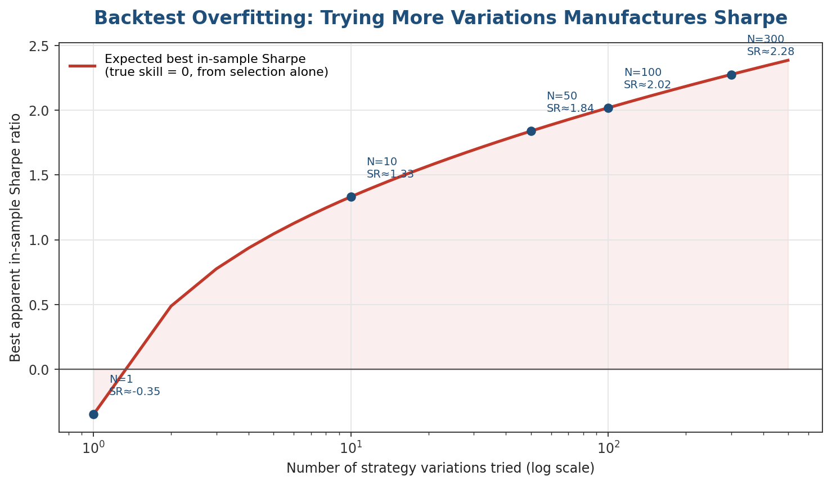
Figure 1.2 — Even with zero genuine skill, trying 100 strategy variations and reporting only the best one is expected to produce an in-sample Sharpe ratio above 2 — a number that would look outstanding on its own, with no way to tell from the backtest alone that it is pure selection artefact.
The underlying intuition comes from extreme value theory (previewed here, developed further in Section 2.1): if you draw N independent samples from a distribution with mean zero, the expected value of the maximum of those N samples grows with N, even though the underlying process has no true edge at all. A commonly used correction is the Deflated Sharpe Ratio, which explicitly adjusts an observed Sharpe ratio downward as a function of the number of trials, the length of the backtest, and the higher moments (skewness, kurtosis) of the strategy's returns:
DSR = Φ ( (SR̂ − SR₀) · √(T−1) / √(1 − γ₃·SR̂ + (γ₄−1)/4·SR̂²) )
where SR̂ is the observed Sharpe ratio, T is the number of return observations, γ₃ and γ₄ are the sample skewness and kurtosis, Φ is the standard normal CDF, and SR₀ is the expected maximum Sharpe ratio from the number of independent trials conducted — approximately the curve plotted in Figure 1.2. A DSR meaningfully below 1 (roughly, below a 95% confidence threshold) suggests the observed Sharpe ratio has not been convincingly distinguished from what selection alone would produce.
Common mistake: Reporting a strategy's Sharpe ratio without disclosing, even internally, how many variations were tried before arriving at it. A Sharpe ratio of 1.8 from the single best of 3 sensible variations is a very different claim from a Sharpe ratio of 1.8 that emerged as the best of 300 combinations swept across a grid — the backtest itself cannot tell the two apart, but the deflated Sharpe ratio calculation, and honest record-keeping of the research process, can.

1.4 Parameter Sensitivity and Robustness Testing
A closely related discipline to overfitting detection is testing how sensitive a strategy's performance is to small, reasonable changes in its own parameters. A genuinely robust strategy should perform reasonably well across a neighbourhood of parameter choices, not just at the single specific combination that happened to backtest best — a sharp, narrow performance peak surrounded by mediocre or poor performance is itself a strong warning sign of overfitting, even without knowing exactly how many variations were tried.
Robustness check | What it tests | Warning sign
Parameter heatmap / surface | Performance across a grid of two key parameters (e.g. lookback window × entry threshold). | A single sharp peak rather than a broad, gently-varying plateau of good performance.
Leave-one-period-out | Re-run the backtest repeatedly, excluding one sub-period (e.g. one year) at a time. | Performance depends heavily on one or two specific sub-periods rather than being broadly distributed.
Walk-forward re-estimation | Refit parameters on a rolling window and test only on the immediately following unseen period. | Walk-forward performance is materially worse than the single full-sample backtest.
Universe perturbation | Add or remove a small number of securities from the tradable universe. | Performance is driven by a small handful of names rather than being broad-based.
None of these checks proves a strategy is free of overfitting — that is generally not provable from historical data alone — but a strategy that fails several of them simultaneously should be treated with far more scepticism than its raw backtested Sharpe ratio alone would suggest.

1.5 Worked Example: Applying the Deflated Sharpe Ratio
To make Section 1.3's formula concrete, consider a researcher who tested 80 variations of a mean-reversion strategy — different lookback windows, entry thresholds, and universe filters — over a five-year daily backtest (T ≈ 1,260 trading days), and reports the single best combination: an annualised Sharpe ratio of 1.6, with returns that are mildly negatively skewed (γ₃ = −0.4) and moderately fat-tailed (γ₄ = 5.0, versus 3.0 for a normal distribution).
Step 1 — estimate the benchmark SR₀ from N = 80 trials using the extreme-value approximation from Figure 1.2 (converted to the same daily-to-annual scaling used for the observed Sharpe ratio):
SR₀ ≈ [ √(2 ln 80) − γ / √(2 ln 80) ] × √(1/T) × √252 ≈ 0.62
Step 2 — plug SR̂ = 1.6, SR₀ = 0.62, T = 1,260, γ₃ = −0.4, and γ₄ = 5.0 into the DSR formula from Section 1.3. The numerator (SR̂ − SR₀)·√(T−1) is large and positive because the observed Sharpe ratio comfortably exceeds the noise benchmark; the denominator is inflated somewhat by the fat tails (γ₄ > 3), which widen the effective standard error of the Sharpe ratio estimate itself:
DSR = Φ( 34.4 / √(1 + 0.4×1.6 + 1.0×1.6²/4) ) = Φ(24.9) ≈ 1.00
In this example the observed Sharpe ratio survives the correction comfortably — DSR ≈ 1.00 indicates the result is essentially certain not to be a pure artefact of the 80 trials conducted, given how far above the noise benchmark it sits. The exercise is far more informative when the gap is narrower: a strategy reporting a raw Sharpe ratio of 0.9 from 200 trials, for instance, would produce a DSR meaningfully below the conventional threshold, correctly flagging that its apparent edge cannot be confidently distinguished from selection alone.
Tip: The DSR calculation requires an honest count of N, the number of trials — which means the single most important input to the whole calculation is a research-process discipline (logging every variation tried, not just the winner) rather than a mathematical one. A perfectly executed DSR formula applied to a dishonestly low N is worse than no correction at all, because it creates false confidence.

Part 2 — Tail Risk, Stress Testing, and Governance
Part 1 covered model risk arising from how a model is built and estimated. This part covers a specific, recurring blind spot in almost every model built on standard statistical assumptions: the tails. It then covers the practical discipline of stress testing a model directly against extreme scenarios, and the governance processes that make independent validation and ongoing monitoring routine rather than exceptional.

2.1 Fat Tails and Extreme Value Theory
Most of the models introduced earlier in this curriculum — including CAPM, Black-Scholes' underlying process before its volatility surface extensions, and standard Value-at-Risk calculations — rely, explicitly or implicitly, on some form of normal (Gaussian) distributional assumption. Real financial returns are reliably fatter-tailed than the normal distribution: extreme moves happen far more often than a normal distribution calibrated to the same mean and variance would predict. Figure 2.1 makes the scale of this understatement precise.
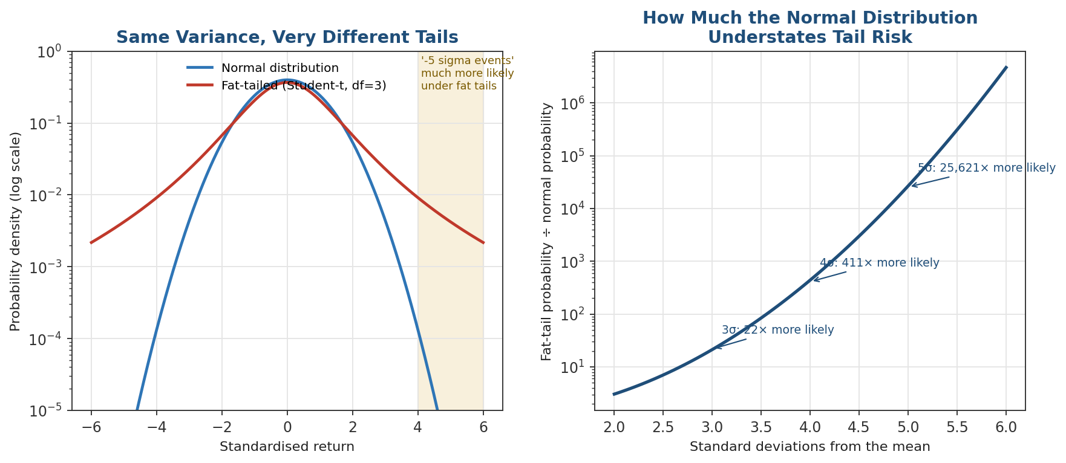
Figure 2.1 — A fat-tailed distribution (here, a Student-t with 3 degrees of freedom) can share the same variance as a normal distribution while making extreme events dramatically more likely — a 5-standard-deviation event is over 25,000 times more likely under the fat-tailed distribution shown here.
Extreme Value Theory (EVT) addresses this directly by modelling the tail of a distribution on its own terms, rather than relying on a single distributional assumption fitted mainly to the well-populated centre of the data. The Fisher-Tisher-Gnedenko theorem justifies fitting a Generalised Pareto Distribution (GPD) specifically to observations that exceed some high threshold u:
P(X − u ≤ x | X > u) ≈ GPD(x; ξ, β) = 1 − (1 + ξ x/β)^(−1/ξ)
where ξ is the shape parameter (governing how fat the tail is — ξ = 0 recovers a thin, exponential-like tail, while ξ > 0 indicates a genuinely fat, power-law-like tail) and β is a scale parameter. Once fitted, the GPD gives tail risk measures (e.g. a 99.9% Value-at-Risk, well beyond the range of most historical data) that are grounded in the theory of how tails behave, rather than extrapolated from a distributional assumption that was never designed to describe them.
Why this distinction matters: A Value-at-Risk model calibrated to historical data using a normal-distribution assumption will systematically understate the probability of a genuinely extreme loss, and will do so most severely for exactly the tail percentiles (99.5%, 99.9%) that matter most for capital adequacy and regulatory reporting. This is not a minor technical footnote — it was a central, well-documented failure mode of pre-2008 bank risk models.

Worked example: comparing normal and EVT-based Value-at-Risk
Suppose a portfolio has a daily return standard deviation of 1.5% and a mean close to zero. A standard normal-distribution 99.5% one-day Value-at-Risk is:
VaR₉₉.₅% = σ × Φ⁻¹(0.995) = 1.5% × 2.576 ≈ 3.86%
Now suppose an EVT analysis of the same portfolio's historical losses beyond a high threshold finds a fitted GPD shape parameter ξ = 0.25 (a genuinely fat tail) and scale β = 1.1%, using a threshold u set at the 95th percentile of losses. The EVT-based 99.5% VaR is obtained by inverting the tail probability under the fitted GPD:
VaR₉₉.₅% = u + (β/ξ) × [ (n/n_u × (1−0.995))^(−ξ) − 1 ] ≈ 5.9%
In this illustrative example, the EVT-based estimate is roughly 50% higher than the normal-distribution estimate for the same portfolio and the same confidence level — a difference that, multiplied across a large trading book, is the entire difference between a capital buffer that comfortably survives a genuine tail event and one that does not. The gap between the two estimates widens further, often dramatically, at higher confidence levels (99.9% and beyond), which is precisely where the normal distribution's understatement of tail risk is most severe.

2.2 Tail Dependence and Copulas
A second, related blind spot concerns not the tail of a single variable but the joint tail behaviour of two or more variables — whether assets that are only moderately correlated on an ordinary day become far more correlated during a crisis. Ordinary (Pearson) correlation, and the multivariate normal distribution built on it, cannot distinguish this from ordinary correlation that stays constant through both calm and stressed periods. A copula separates a joint distribution's marginal behaviour from its dependence structure, and different copula families make very different assumptions about tail dependence for the same overall correlation.
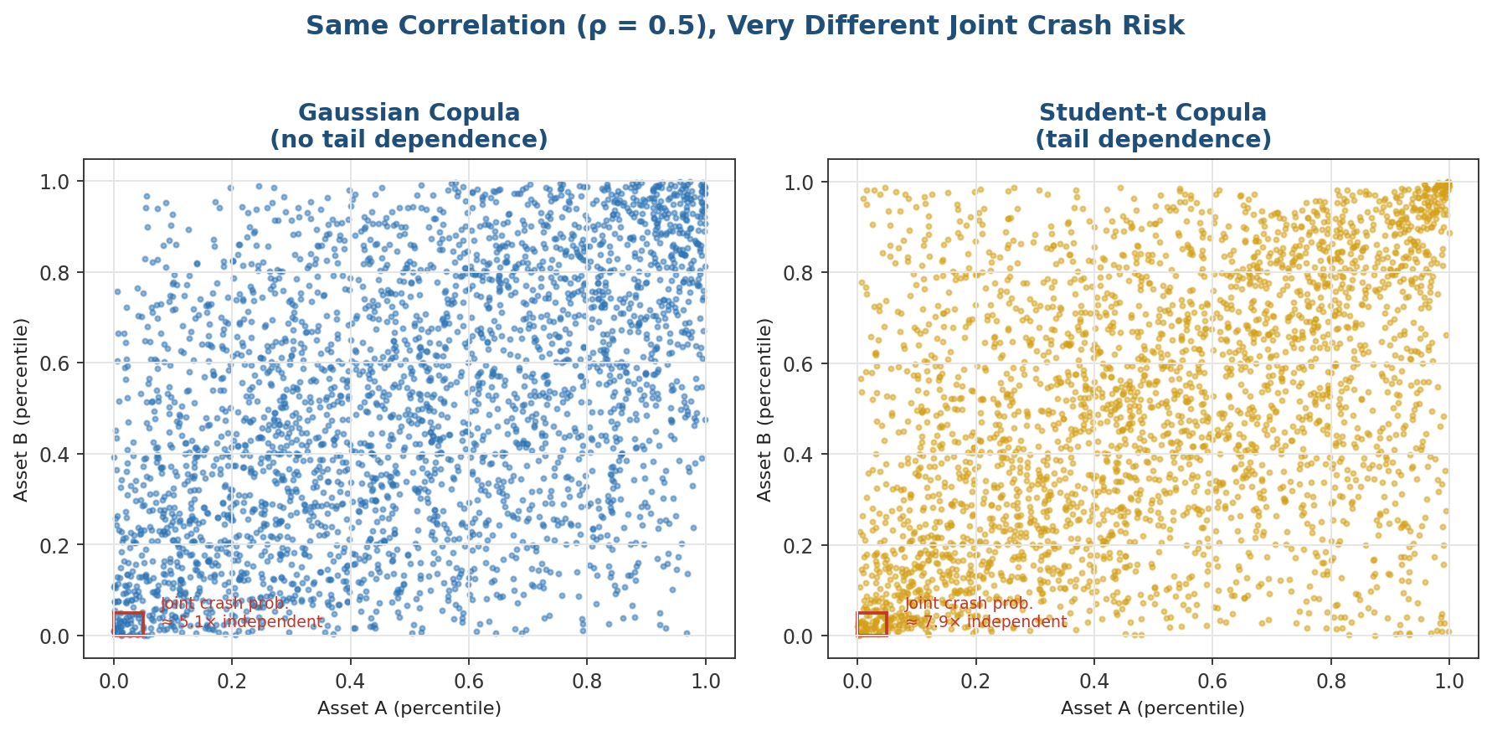
Figure 2.2 — Both panels are simulated with identical overall correlation (ρ = 0.5). The Gaussian copula's joint-crash probability is close to what independence would imply; the Student-t copula's is materially higher, because it has genuine tail dependence built into its construction.
Formally, the (upper) tail dependence coefficient measures the limiting probability that one variable is extreme, given that another already is:
λ_U = lim(q→1⁻) P(Y > Fₑ⁻¹(q) | X > Fₓ⁻¹(q))
For a Gaussian copula, λ_U = 0 for any correlation strictly less than 1 — the Gaussian copula assumes joint extremes become relatively rarer, not more common, as the threshold gets more extreme. This single mathematical property was central to the mispricing of correlated mortgage default risk before 2008: a Gaussian copula model of default correlation implied that a nationwide, simultaneous wave of defaults was far less likely than it actually turned out to be, because the model's tail dependence was, by construction, zero.
Common mistake: Estimating an ordinary correlation matrix from historical data and assuming it fully describes how a portfolio will behave in a crisis. Two assets can show a modest 0.3 correlation in normal markets and behave almost identically during a systemic sell-off; a correlation matrix and a Gaussian assumption alone cannot represent that shift, which is exactly what a copula with genuine tail dependence, or a direct stress test (Section 2.3), is designed to capture.

2.3 Stress Testing and Scenario Generation
Where EVT and copulas model tail risk statistically, stress testing evaluates a specific model or portfolio's behaviour directly against a concrete, severe scenario, sidestepping the question of exactly how probable that scenario is. Two broad approaches are used in practice, often together: historical scenarios replay an actual past crisis's market moves against today's portfolio, and hypothetical scenarios construct a plausible but never-yet-observed shock designed to probe a specific vulnerability (e.g. a sudden 200 basis point overnight rate move, or a simultaneous liquidity freeze across correlated markets).
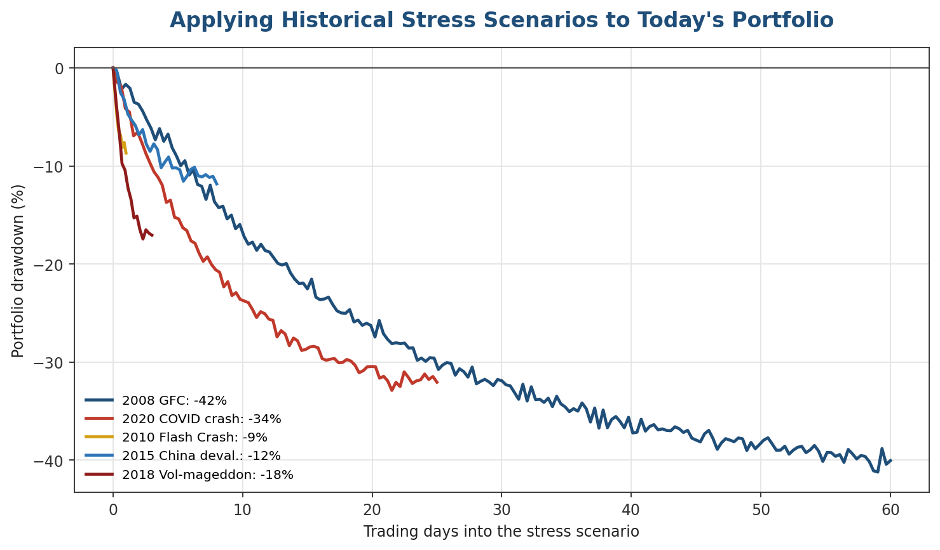
Figure 2.3 — The same portfolio, replayed against five different historical stress scenarios, shows very different depth and duration of drawdown — which is exactly the point: a single 'worst case' number hides how differently a portfolio behaves depending on the nature of the shock.
A well-constructed stress-testing programme reports more than a single worst-case loss number. It typically distinguishes the depth of the loss, the speed at which it occurred (a one-day flash crash stresses execution and liquidity risk very differently from a two-month grind lower), and the assumptions the scenario makes about liquidity — whether the portfolio can actually be traded, at what cost, during the scenario, which is often the most understated risk in a naive stress test.
Scenario | Nature of the shock | Key risk it probes
2008 Global Financial Crisis | Prolonged, multi-month decline with a severe credit and liquidity freeze. | Correlation breakdown across asset classes; funding and margin-call risk.
2020 COVID crash | Extremely fast, deep decline followed by an equally fast recovery. | Whether a strategy can survive a severe drawdown without being forced to de-risk near the bottom.
2010 Flash Crash | Single-day, extreme intraday move that partially reversed by the close. | Execution and market-structure risk; stop-losses or margin triggers firing on a transient move.
2015 China devaluation | Sudden policy-driven shock originating outside the primary market. | Cross-asset and cross-region contagion from an unexpected source.
2018 'Vol-mageddon' | Sharp, sudden spike in volatility itself, distinct from a large price move. | Strategies short volatility or short gamma, which can suffer even without a large underlying price move.
Tip: A stress test that a model or portfolio has never failed is informative only insofar as the scenarios tested were genuinely severe and genuinely varied. Testing only mild, similar scenarios and concluding a model is 'robust to stress' is a common and dangerous form of validation theatre — the practical exercise in this module deliberately asks you to test against scenarios the strategy was never tuned on, for exactly this reason.

2.4 Model Governance and Independent Validation
Everything covered so far in this module — checking for misspecification, monitoring parameter stability, correcting for overfitting, and stress testing against tail scenarios — is validation technique. Model governance is the organisational discipline that ensures these techniques are actually applied, by people with the right incentives, before a model is trusted with real capital, and continuously afterward. Figure 2.4 shows the lifecycle a model should pass through at a well-run institution.
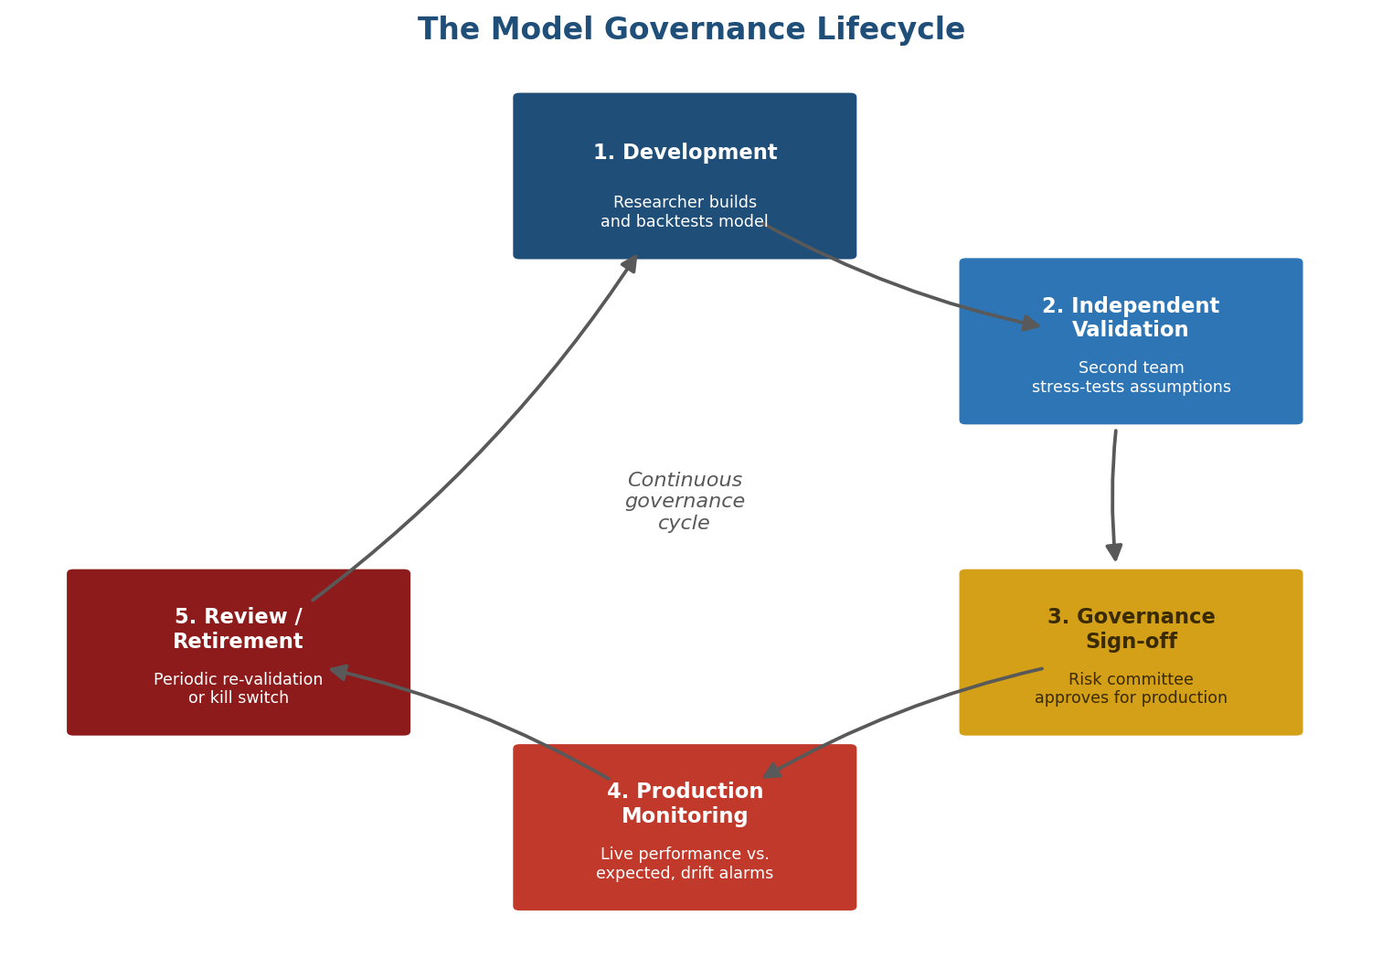
Figure 2.4 — Governance is a cycle, not a one-time gate: production monitoring routinely triggers a return to earlier stages when a model's live behaviour drifts from what was validated.
The single most important structural feature of this lifecycle is captured in stage 2: independent validation must be performed by a team or individual without a stake in the model's success. A researcher who built and backtested a strategy is poorly positioned to find its flaws — not through dishonesty, but because months of work on a model create a natural, well-documented cognitive bias toward interpreting ambiguous results favourably. Separating development from validation is the organisational answer to a problem that individual discipline alone reliably fails to solve.
Governance role | Core responsibility | Key question they must be able to answer
Model developer | Builds, backtests, and documents the model's assumptions and limitations. | What does this model assume, and where do I expect it to break?
Independent validator | Reviews the model without the developer's assumptions, stress-tests it directly. | Does this model survive scrutiny it was not specifically built to survive?
Risk committee | Approves, limits, or rejects the model's use in production based on validation findings. | Given known limitations, what capital or position limit is appropriate?
Model owner / desk | Monitors live performance against validated expectations, escalates drift. | Is this model still behaving the way it did when it was validated?
Why this distinction matters: Regulatory frameworks in banking (e.g. the Federal Reserve's SR 11-7 guidance in the US) formalise almost exactly this lifecycle, requiring independent model validation as a distinct function from model development. The same logic applies, in a lighter-weight form, to any trading operation: a hedge fund without any form of independent review of its own strategies is relying entirely on the same researchers' incentives and blind spots that built the strategies in the first place.

Monitoring metrics in practice
Stage 4 of the governance lifecycle — production monitoring — is only as good as the specific, quantitative metrics it tracks. A monitoring dashboard built around vague, qualitative checks ('does the strategy still seem to be working?') will consistently detect problems later than one built around the concrete metrics below, compared automatically against the ranges observed during validation.
Metric | What it detects | Typical trigger for escalation
Rolling realised Sharpe ratio | Broad performance degradation relative to the validated backtest. | Materially below the backtested Sharpe ratio over a sustained rolling window.
Parameter drift (e.g. rolling beta, volatility) | The regime change described in Section 1.2, in real time. | Estimate moves outside the range observed during validation's historical sample.
Realised vs. predicted risk (e.g. VaR breach rate) | A risk model quietly understating actual portfolio risk. | VaR breaches occurring more often than the model's own confidence level implies.
Turnover and capacity utilisation | Strategy behaviour drifting from what was backtested (e.g. due to slippage or crowding). | Live turnover or market-impact costs diverge materially from backtested assumptions.
None of these metrics is a substitute for periodic, full re-validation — they are the tripwires that determine when an unscheduled re-validation should happen sooner than the regular schedule would otherwise dictate.

Practical Exercise
Take a validated strategy (for instance, one built in an earlier module of this curriculum) and stress-test it against three historical extreme scenarios — for example, 2008, the 2020 COVID crash, and a flash crash — that it was not explicitly trained or tuned on.
- Select or construct historical return series for your three chosen stress windows, at the same frequency the strategy trades (daily is sufficient for most strategies covered so far in this curriculum).
- Confirm, explicitly and in writing, that none of the strategy's parameters were fitted or tuned using data from these specific windows — if they were, select different, genuinely out-of-sample scenarios.
- Run the strategy's actual position-sizing and trading logic against each scenario's price path, not just a simplified 'apply the market's return to the whole portfolio' approximation.
- Report, for each scenario: peak-to-trough drawdown, time to recovery (if recovery occurred within the scenario window), and whether any risk limit, margin constraint, or stop-loss would have been breached.
- Compare the strategy's stressed performance to its normal backtested performance, and write a short assessment of whether the strategy's position size or risk limits should change as a result.
import numpy as np, pandas as pd
def stress_test(strategy, scenario_prices, scenario_name):
positions = strategy.generate_positions(scenario_prices) # reuse actual logic, not a proxy
pnl = (positions.shift(1) * scenario_prices.pct_change()).sum(axis=1)
cum_pnl = (1 + pnl).cumprod() - 1
peak = cum_pnl.cummax()
drawdown = cum_pnl - peak
return {
'scenario': scenario_name,
'max_drawdown': drawdown.min(),
'days_to_trough': (drawdown.idxmin() - cum_pnl.index[0]).days,
'limit_breached': bool((drawdown < -strategy.max_drawdown_limit).any()),
}
scenarios = {
'2008 GFC': load_prices('2008-09-01', '2008-11-30'),
'2020 COVID crash': load_prices('2020-02-15', '2020-03-23'),
'Flash Crash': load_prices('2010-05-06', '2010-05-06'),
}
results = [stress_test(my_strategy, prices, name) for name, prices in scenarios.items()]
print(pd.DataFrame(results))
Common mistake: Approximating a stress scenario by simply shifting the whole portfolio's value by the broad market's return during that period, rather than running the strategy's own position-sizing and trading logic through the scenario. A strategy that dynamically de-risks in a sell-off can behave completely differently from a static buy-and-hold approximation of the same scenario — the whole point of the exercise is to find out whether the strategy's own logic protects it or compounds the damage.

Common Beginner Mistakes
Mistake 1 — Validating on the same data or period the model was developed on: Re-running a backtest on the same historical window used to build and tune the model, and treating a good result as confirmation of validity. This tests whether the model was fitted correctly, not whether it will generalise — genuine validation requires data, or scenarios, the model's development process never had access to (Sections 1.3 and 2.3).
Mistake 2 — Treating a model's assumptions as facts rather than testable approximations: Building years of infrastructure and decision-making on top of a model's output without periodically revisiting whether its founding assumptions — normal returns, stable correlations, a particular volatility process — still hold. Every assumption introduced in this curriculum was a deliberate simplification, made explicit specifically so it could later be tested and, if necessary, revised.
Mistake 3 — Confusing the absence of a failure with the presence of robustness: Concluding a model is safe because it has not yet failed in live use, rather than because it has been deliberately tested against the conditions most likely to break it. A model can run successfully for years precisely because the regime it depends on has not yet shifted — which is a statement about the environment, not evidence about the model's underlying robustness (Sections 1.2 and 2.3).

Advanced Extensions
The natural next step beyond this module is formal model-risk-management frameworks as used at regulated institutions, most notably the US Federal Reserve's SR 11-7 guidance and the parallel frameworks used by European and UK regulators. These frameworks formalise almost every concept in this module into an auditable process: a required model inventory (every model in use, with an owner and a risk tier), mandatory independent validation before deployment and on a periodic schedule afterward, documented 'effective challenge' of a model's assumptions, and explicit escalation procedures when ongoing monitoring detects performance drift. Understanding these frameworks in detail is essential for anyone working in, or alongside, a regulated bank's model risk function, and is valuable more broadly as a mature, battle-tested template for building governance into a smaller trading operation.
Three specific extensions are worth naming for further study once the core material in this module is comfortable:
- Model risk tiering — formal frameworks typically classify models into risk tiers (e.g. based on capital impact or the extent of human oversight in the decision loop) and scale the intensity of validation — how often it is repeated, how many independent reviewers are required — to the tier, rather than applying one fixed process to every model regardless of its stakes.
- Effective challenge documentation — regulators specifically look for evidence that a model's assumptions were genuinely questioned, not merely reviewed and rubber-stamped; mature frameworks require validators to document the specific alternative assumptions or specifications they considered and why they were rejected.
- Aggregated model risk reporting — beyond validating individual models, mature frameworks aggregate model risk across an entire firm, tracking how many models are overdue for revalidation, how many have open, unresolved validation findings, and how concentrated the firm's overall risk-taking is in a small number of un-diversified modelling approaches.

Professional Applications
- Independent model validation functions — dedicated teams at banks, asset managers, and larger hedge funds whose sole responsibility is the critical review described throughout this module, structurally separated from the teams that build the models.
- Risk committees — governance bodies that review validation findings and make the final call on whether, and under what limits, a model is approved for live use, forming the decision-making layer above the technical validation work.
- Capital allocation governance — the process, informed directly by stress-testing and model-risk assessments, of deciding how much capital or risk budget any given strategy or business line is permitted to run, rather than allocating purely off historical Sharpe ratios.
These functions typically map onto a small number of recurring, quotable deliverables, summarised below.
Deliverable | Typical audience | Core content
Model validation report | Risk committee, regulators | Specification review, parameter stability analysis, stress-test results, and a recommended risk tier or limit.
Ongoing monitoring dashboard | Model owner, desk head | Live performance versus validated expectations, parameter drift alerts, and outstanding validation findings.
Stress-test summary | Risk committee, senior management | Portfolio or firm-wide performance under the historical and hypothetical scenarios from Section 2.3.
Model inventory and risk register | Regulators, internal audit | Every model in use, its owner, risk tier, and validation/revalidation status.

Where to Go Next
This module completes the risk-management side of the curriculum's advanced track by turning the same critical scrutiny back onto every model the curriculum has built — pricing models, factor models, systematic strategies, volatility models, and the risk metrics used to size and monitor all of them. Where earlier advanced modules (High-Frequency Trading, Advanced Derivatives/Volatility) went deeper into specific trading disciplines, this module is deliberately cross-cutting: its lessons apply to every one of them, and to whatever comes next.

Suggested paths depending on your focus
- Heading into research: focus on Section 1.3's overfitting correction techniques — the deflated Sharpe ratio and its underlying multiple-testing logic should become a standing part of how you evaluate every future backtest, not a one-off calculation for this module alone.
- Heading into infrastructure/development: focus on Section 2.4's governance lifecycle — building the versioning, sign-off tracking, and automated drift-monitoring infrastructure that makes a governance process actually operable, rather than a document nobody consults, is substantial and valuable engineering work.
- Heading into trading or risk management: focus on Part 2 in full, and take the practical exercise seriously on a strategy you actually intend to trust with capital — the discipline of stress-testing your own work, honestly and adversarially, is the single most transferable skill this module teaches.

